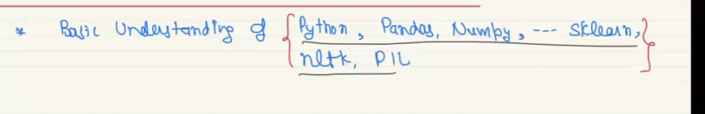

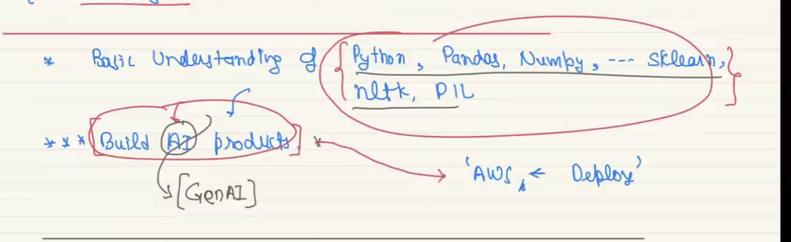

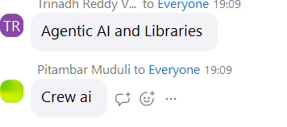

Stream lit for building chatbat

Flask